Keep your vehicle in a good Condition
In winter, it is important to check that your vehicle is well maintained.
Keep the lights, windows and mirrors clean and free from ice and snow & add a winter additive to the washer bottle before setting out. Check that tyres have plenty of tread and are at the correct pressure.
Adjust your driving to the conditions
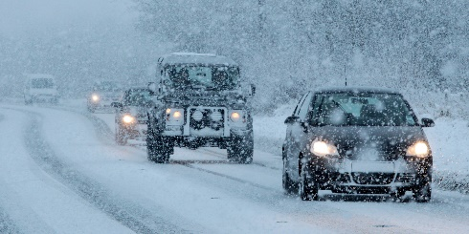
Driving in low visibility or on icy or wet roads requires a very different driving style. There are some simple steps you should take to ensure your safety when exposed to the different driving hazards. By reducing your speed and being aware of your stopping distance the chances of avoiding an incident significantly increase, on icy roads braking distances could be considerably longer than expected. Be aware that other drivers may not have your skills or experience and brake or accelerate unexpectedly.
When roads are affected by snow, ice or slush
- It can take ten times longer to stop, so drive slowly, allowing extra room to slow down and stop;
- Do not engage cruise control as this may affect the vehicles handling capabilities and will reduce your overall control;
- When accelerating, use the highest gear possible to prevent your wheels from spinning;
- Manoeuvre gently, avoiding harsh braking and acceleration;
- To brake without locking your wheels, use a low gear earlier than normal so your engine will smoothly reduce your speed and use your brake pedal gently;
- If you do start to skid, ease off the accelerator and do not brake suddenly;
- When driving in hail, heavy snow or rain, use your dipped headlights and reduce your speed.
In foggy conditions
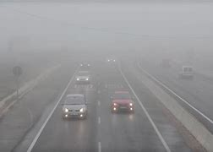
- Expect visibility to deteriorate rapidly as fog drifts quickly and can be patchy;
- Don't speed up suddenly, even if it seems to be clearing, as you can suddenly find yourself back in thick fog;
- Drive very slowly and use your dipped headlights;
- Use fog lights if visibility is seriously reduced, but remember to switch them off when visibility improves;
- Don't hang on to the tail lights of the vehicle in front, as you may well be driving too close.
If you do get into trouble
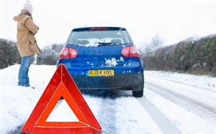
- Do not use a mobile phone while driving. Instead, stop somewhere safe or ask a passenger to make the call;
- On a motorway, it is best to use a roadside emergency telephone, because it will help the breakdown/emergency services to locate you easily, if you have to use a mobile phone make sure you know your location from the numbers on the marker posts positioned at the side of the hard shoulder.
- Abandoned vehicles can hold up rescue vehicles and snow ploughs, so to ensure that the road is cleared as quickly as possible, stay with your vehicle until help arrives.
- If you have to leave your vehicle to get help, make sure other drivers can see you clearly.(Wear PPE including HI Visibility Jacket if available)

Additional Recommendations
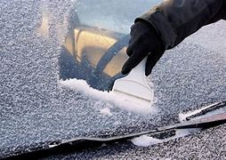
Before starting out on your journey, ensure your mobile phone is fully charged and working, in case you find yourself in difficulty and need to contact someone.
Remove all snow/ice from your windows, mirrors and lights, do not forget the roof.
It may also be prudent to prepare yourself a hot beverage in a flask to carry in your vehicle along with bottled water, food and snacks in case you get into trouble on your journey, or need to pull over for an extended period. Also, carry a shovel, torch with spare batteries and spare warm clothing and a reflective triangle.
Allow more time for your journey and ensure you take a little longer to prepare your vehicle for your travel including daily checks.
Ensure you are wearing adequate warm clothing as you would be vulnerable to the cold if your vehicle broke down with no form of heating.
Watch out in low winter sun
The low winter sun can dazzle even the most confident and experienced drivers. The glare can easily impair your vision and cause you to miss signs and lights, or pedestrians crossing the road. If you cannot see very well, chances are that other road users can’t either.
- Reduce your speed or stop all together.
- Wear sunglasses in bright sunlight
- Make sure your windscreen and all vehicle windows are clean, both inside and out.
Security
- Try to park in a well-lit area and remove all valuables from your vehicle;
- Ensure that your vehicle is locked and that the alarm and immobiliser have been activated;
- Check your vehicle for damage prior to leaving and upon return.
Key Points:
- DRIVE ACCORDING TO THE CONDITIONS – black ice, low winter sun, hail, slush & snow can pose hazardous driving conditions & make your vehicle difficult to control. Practice smooth steering, accelerating & braking techniques to minimise potential for skids or loss of vehicle control;
- Ensure your vehicle is always maintained in good condition;
- Prior to undertaking your commute to/from work, check weather forecasts & plan your journey accordingly;
- During periods of low temperatures always assume roads are icy and treacherous, even on treated surfaces;
- Always wear your seat belt & use dipped headlights;
- Always keep a safe stopping distance from the vehicle in front.

