Each winter there are several serious injuries and incidents caused by hazards particular to the season. This toolbox talk has been issued to raise awareness of seasonal hazards and to act as a prompt to our project teams to help prepare for Winter.

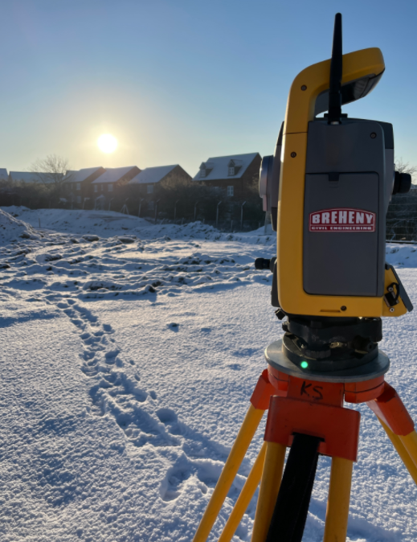 | Winter is upon us again. We all must take time and plan to put in place the controls for the coming hazards. Please review the following and ensure readiness for Winter conditions
 | Access Routes – Arrangements for keeping access routes, pedestrian routes, and compound areas safe and useable. This includes minimising the impact our works have on the public; e.g. adequate stockpiles of grit, keeping paths and roads safe to use, etc.
Emergency Procedures – Are there arrangements in place to deal with emergencies?
Have points of contact been identified and their details communicated?
 | Exclusion Zones – Provision of segregation between people and plant/vehicles and the establishment of exclusion or restricted zones is essential in preventing incidents
Lighting requirements – Is general and task lighting suitable?
In particular where people are required to walk or work in areas of darkness including between work locations
Increased hazards due to winter conditions

- Slips & trips
- Poor visibility – during
- snowfalls or frosted windows
- Items being frozen together
  - manual handling injuries
- Frozen ground – harder digging
- Cold-induced fatigue
- Greater risk of HAVS exposure due to cold conditions
- Sickness/illnesses
 | PPE requirements – Do all personnel have suitable PPE for adverse weather?
Welfare Provision – Are the welfare units fit for purpose?
Including functioning heating and sufficient drying facilities – remember, Covid-19 is still with us, we must maintain our Covid mitigation measures
In addition, ensure that all risk assessments and method statements for ongoing activities are up to date and valid for the winter season.
Be ready for these situations in advance by having in place a strategy for making, communicating, and amending works instructions.

Contingency Planning
An essential element of successfully ensuring everyone goes home safe every day, is being prepared for unplanned events such as challenging environmental conditions, adverse weather, limited resources, etc. Planning for worst-case scenarios in advance can help ensure that unforeseen events can be managed in a controlled and safe manner. Ongoing two-way communication between contractors, our clients, and other stakeholders will minimise any detrimental effects of the winter season.

