Introduction
Manual handling causes over a third of all workplace injuries. These include work-related musculoskeletal disorders (MSDs) such as pain and injuries to arms, legs, and joints, and repetitive strain injuries of various sorts.
The term manual handling covers a wide variety of activities including lifting, lowering, pushing, pulling, and carrying. If any of these tasks are not carried out appropriately there is a risk of injury.
What does the law say?
The Manual Handling Operations Regulations 1992 set out a clear hierarchy of measures for dealing with risk likely to cause harm from manual handling. These are:
- avoid hazardous manual handling operations so far as reasonably practicable;
- assess any manual handling operations that cannot be avoided;
- reduce the risk of injury too as low as reasonably practicable.
The Regulations also require employees to follow systems of work laid down by the employer to promote safety in the manual handling of loads.
What is the risk?
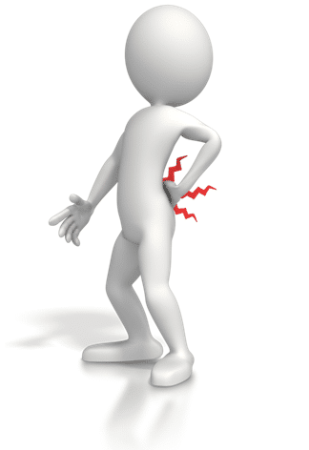
Incorrect manual handling is one of the most common causes of injury at work. It causes work-related musculoskeletal disorders (MSDs) which account for over a third of workplace injuries. The term ‘musculoskeletal disorders’ covers any injury, damage, or disorder of the joints or other tissues in the upper / lower limbs or the back. These injuries can be highly debilitating and often result in time off work with an average of 16 days lost for each case. The construction sector loses 1.2 million working days due to ill health, 64% of which resulted from work-related MSDs.
Many MSDs take a long time to develop and are not a result of a single incident. There is also evidence that heavy manual labour, awkward postures, repetitive actions, and existing injuries are all risk factors in the development of MSDs
Typical high-risk manual handling risks in construction
Any task that involves exerting a force on another object including lifting, lowering, pushing, or pulling is considered “manual handling”.
Typical Manual handling tasks undertaken on a Breheny Project
Block Laying | Erection and Dismantling of Signage | Operation of Handheld Compactors
Laying of drainage – handling, plastic, ceramic and concrete pipes, and fittings | General Shovelling and Raking | Installation of TM
Installation/removal of Manhole Covers/lids etc. | Use of bagged aggregates / Cement | Use of Disc Cutters
A common misconception is that any load of less than 25kg can be safely lifted by an individual. In fact, this figure is based on what a healthy adult male can reasonably carry in his trunk region, close to his body. This figure drops dramatically as the load is moved away from the body or lowered or raised. Different figures are also available for females.
Assessing the risk
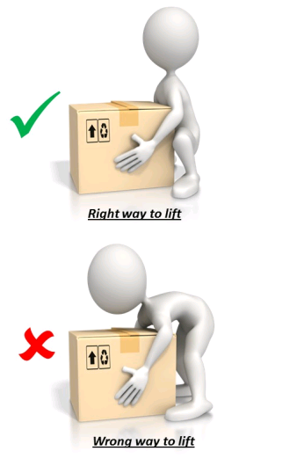
Works must be planned to minimise the risks associated with manual handling. A safe system of work must be developed that enables the task to be undertaken safely, without personal injury.
When assessing risks the following should be considered:
- weight of the load
- size and shape of the load
- posture during manual handling
- the distance you have to lift or lower the load
- nature of the manual handling movement
- frequency of the manual handling task
- working environment:
- bumpy, obstructed, or slippery floors
- variations in floor levels
- hot/cold/humid conditions
- gusts of wind or other strong air movements
- poor lighting conditions
- restrictions on movements from clothes or personal protective equipment (PPE)
- the capability of the individual
Manual handling Risk Assessment must be recorded on BCE CP form 10/17.
Risks identified in the assessment must be reduced, so far as is reasonably practicable, by taking ‘appropriate’ steps. The effectiveness of measures taken should be monitored and, if they do not have the desired effect, the situation should be reappraised.
Where practicable, mechanical lifting devices must be employed e.g. sack barrows, forklift trucks, cranes and hoists, etc.
Site Supervision must ensure that all persons undertaking any manual handling operation have received adequate instruction, information, and training and are physically fit and capable.
Employees and contractors must comply with the control measures identified within the Risk Assessment, and use any equipment supplied in an appropriate manner. They shall also advise their line manager of any restrictions they have relating to manual handling activities.
Before lifting, think TILE
T – Task - Does the task involve repetitive movements, strenuous movements, long distances, or uneven weight distribution?
I – Individual - Is one person capable of manual handling alone? Do they need assistance?
L – Load - Is the load particularly heavy, bulky, hard to grasp, or unstable?
E – Environment - Is the floor slippery or uneven? Is there sufficient lighting? Are there any trip hazards?

Guidance
The Task | Consider, before lifting, where the load is to be shifted to and from, take into account the distance to travel, the weight of the load, the conditions at the end where the load is to be taken to. Consideration should be given in planning the movement of loads to prevent repetition. Persons involved in manual handling tasks shall receive instruction and training in manual handling techniques as part of their induction process and from ongoing toolbox talks.
Individual Capability | Any assessments by the individual must include his or her capability to move the load. Each person will have a different threshold.  Normally, loads are not marked to give their weight, but by surveying the load, or by trying to move it by rocking it back and forth, without lifting the object, can determine whether or not it’s within the individual’s capability. Assistance must be requested if the load cannot be carried by the individual.
The Load | Determine whether moving the load is within your capability, to lift or move on your own. It could be too heavy, bulky, difficult to grasp, or likely to shift whilst in motion (water carrier). Whilst assessing the load, consideration should be given to breaking it down into more manageable parts in order to reduce the risk of injury.
The Environment | The environment in which the load has to be moved can have a large impact on the capability to move the load safely. Uneven or slippery ground conditions, space constraints, and adverse weather conditions can affect the capability to move the load safely. On Customer sites, consideration shall also be given to other operations, which are occurring within the area required to move the load.
Lifting Techniques | Get close to the load,  Obtain a firm grip- using gloves if necessary,  Bend the knees to get down to the load,  Lift the load in one movement- avoid jerking the load,  Do not twist whilst lifting or carrying the load,  Keep the load close to your body; do not extend your arms,  Take care when releasing the load- avoid dropping it.

