**Introduction**

Amongst construction workers, there is a high incidence of respiratory problems, with the main cause being exposure to dusts and respirable crystalline silica (RCS) resulting in silicosis. Other prevalent respiratory diseases amongst construction workers are Chronic Obstructive Pulmonary Disorder (COPD) and asthma. Over 500 construction workers are believed to die from exposure to silica dust every year. The amounts needed to cause this damage are not large

The HSE advise there are currently approximately 12,000 deaths each year due to occupational respiratory diseases. In addition, there are about 35,000 people who worked in the last year, and 130,000 who had ever worked who currently have breathing or lung problems they thought were caused or made worse by work and a further estimated 13,000 new cases.

**What are Respiratory hazards?**

Respiratory hazards are airborne substances or particulates emitted from dusts, such as asbestos fibre and silica, which is found in aggregates, concrete, and mortars, they are also present themselves in fumes and gases.

**What are Construction Dusts?**

|  |
| --- |
| Many common construction tasks can produce high levels of dust, typical examples on a construction site are detailed below:   * Cutting paving blocks, kerbs and flags * Chasing concrete and raking mortar * Cutting roofing tiles * Scabbling or grinding. * Soft strip demolition * Dry sweeping * Cutting and sanding wood * Sanding taped and covered plasterboard joints |

This is a general term used to describe different dusts that you may find on a construction site. There are three main types:

* silica dust – created when working on silica containing materials like concrete, mortar and sandstone (also known as respirable crystalline silica or RCS);
* wood dust – created when working on softwood, hardwood and wood-based products like MDF and plywood;
* other “general” dust – created when working on other materials containing very little or no silica. The most common include gypsum (e.g. in plasterboard), limestone, marble and dolomite.

**Health risks**

Anyone who breathes in these dusts should know the damage they can do to the lungs and airways. The main dust-related diseases affecting construction workers are:

* lung cancer;
* silicosis;
* chronic obstructive pulmonary disease (COPD);
* asthma.

Some lung diseases, like advanced silicosis or asthma, can come on quite quickly. However, most of these diseases take a long time to develop.

**Size of dust particles**

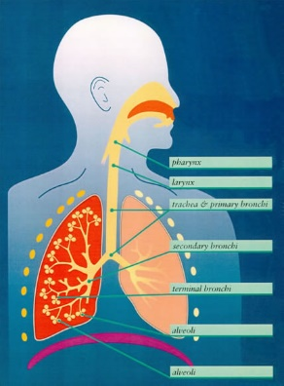The behaviour, deposition and fate of any particular particle after entry into the human respiratory system and the body response it elicits, depend on the size and nature of the particle. Most industrial dusts contain particles of a wide range of sizes.

Two size fractions are important when considering respiratory ill-health; ‘inhalable’ and ‘respirable’ particles.

**Inhalable dust** approximates to the fraction of airborne material that enters the nose and mouth during breathing and is therefore available for deposition in the respiratory tract. Which can then be expelled by coughing and sneezing.

**Respirable dust** approximates to the fraction that penetrates to the gas exchange region of the lung where blood becomes oxygenated. Gas exchange occurs at the alveoli which form the termination points of the respiratory tract.

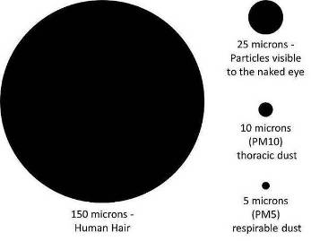To give an idea of how small these particles are it is useful to compare them to the width of a human hair. Respirable particles are particularly small – 10 microns or less when compared to a hair width of around 150 microns.

These respirable dust particles are so small that they are very difficult to see in normal lighting conditions. It is similar in size to the dust you may see floating at home in between a beam of light in an otherwise darkened room.

**Other Sources of Respiratory Hazards**

* Diesel engine exhaust emissions – lung cancer, respiratory irritation;
* Welding – lung cancer, fume fever, occupational asthma, COPD;
* Solvent fumes.

**Controls**

* If you cannot eliminate the use of the substance or substitute it for a safer alternative you will need to think carefully about how to control the use of the substance. It is always safer to control the risk at the source rather than to use PPE;
* A robust COSHH Assessment – a complete risk assessment is needed for all processes e.g. concrete breaking, carpentry works;
* Ensure tasks are risk assessed and assessments have been briefed and are readily available;
* Ensure employees have received adequate training, instruction and information;
* Have things brought in to site prepared off site e.g. pre-painted or pre-cut;
* If necessary get information on airborne dust levels through monitoring;
* Use on tool extraction and ensure it is categorised as Class M. The use of dust collection bags provides minimal dust capture and should not be used on their own as a control measure;
* **DO NOT DRY SWEEP** - this produces high levels of dust;
* Establish Local Exhaust Ventilation (LEV) in fixed work locations;
* Use tools with integrated dust suppression;
* Dust suppression through wet techniques;
* Restrict work areas where dusty operations are occurring;
* Ensure the correct Respiratory Protection Equipment (RPE) is used e.g. Dust masks do not protect against vapour;
* If RPE is being used the operative needs to be face fit tested and clean-shaven when wearing the mask. Know how to use your RPE correctly and how to maintain it, so that it remains fit for purpose;
* Store RPE correctly when not in use, so that it doesn’t become contaminated by the substances you are working with;
* Report any health concerns to your line manager, for example, if you develop any of the above symptoms and if they tend to improve when you are away from work;
* Report any underlying respiratory ill health to your line manager, i.e. asthma
* [Stop smoking](https://www.nhs.uk/smokefree) – this increases your risk of developing lung and chest problems
* Take part in health surveillance programmes when required.

Remember, just because you cannot see dust doesn't mean it isn’t there, respirable dust can be invisible to the naked eye.