Plan
Every site should be organised so that pedestrians and plant can manoeuvre safely. Traffic Management routes should be suitable for the people and item of plant using them. Where plant and pedestrians use the same traffic route, where possible there should be physical segregation of pedestrians from plant by the use of barriers as well as implementation of normal visual or audible warning materials.
Risk Assessment
Prior to the installation of any traffic management system, Site Management must complete a Risk Assessment. Whilst undertaking the Risk Assessment, the protection of pedestrians must be taken into consideration. The contents of the Risk Assessment and Safe System of Work must be communicated to all personnel during the site induction.
The Risk Assessment must be site specific and should address the risks from all work activities involving transport and mobile plant, e.g. driving, loading, parking and maintenance, and assess the impact of these activities on all personnel who may be on site, including employees, contractors, hauliers, visitors and members of the public.
Control
As part of the risk assessment and method statement process, all mobile plant / equipment will be required to have exclusion zones identified. BCE have classified the exclusion zones on level of risk and have coloured coded them in accordance with industry best practice.
Details of the People, Vehicle and Plant Interface Zones must be identified in the Risk Assessment & Method Statement and all of the work teams must be briefed on the exclusion zones and the safe system of entry into the zones
Yellow Zone
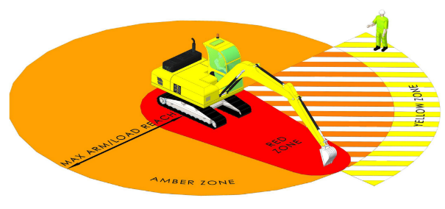
The Banksman must remain within this zone to be able to direct the plant operator. All personnel approaching operating plant must do so from this zone to gain visual contact with the plant operator and authorisation from the before Banksman entering Plant Interface Zones.
Amber Zone
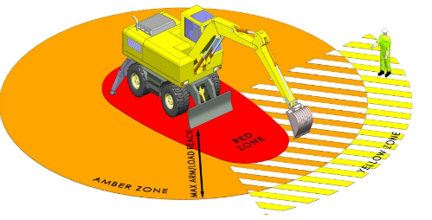
Entry prohibited until positive visual contact is confirmed by the plant operator (e.g. thumbs up), authorisation from the Banksman given, the dipper arm / attachment is grounded, the machine is immobilised using the safety lever and the engine is switched off.
Where work in the amber zone is unavoidable a robust, task specific, safe system of work must be produced
Red Zone
Entry prohibited unless the machine is completely isolated, the engine is switched off and a specific safe system of work is in place that prevents the machine being operated either inadvertently or deliberately.

The following table identify tasks that require working within the amber and red zones. A robust risk assessment and supporting method statement must be in place and communicated to all involved in the task.
- Drainage | - Archaeology
- Piling | - Earth moving
- Bearing tests | - Lifting operations
- Plant maintenance | - Kerb laying
To work within the amber and red zone, a safe system of work must ﬁrstly be in place:
- Ensure the Risk Assessment and Method Statement fully covers the work involved e.g. laying drainage;
- Have a full plan of when and how to enter and exit safely;
- Only the person(s) who need to reach the machine bucket or lifting point areas, may enter a restricted area;
- These person(s) entering must be:
- Experienced in working alongside excavators;
- Fully briefed on working within a restricted red zone;
- Informed on the speciﬁc risks involved in working in close proximity;
- The operator must be able to see the person(s) working in the restricted red zone at all times;
- Agree on the means of communication to be used e.g. radios, verbal or hand signals.
To enter the red zone:
- Make eye contact with the operator;
- Indicate that you wish to approach;
- Wait for the operator to ground the excavator’s bucket/attachment;
- Wait for the operator to isolate the machine and switch the engine off;
- Only approach once the operator indicates with a “thumbs-up” that it is safe to do so;
- Only approach through the amber zone;
- Leave by the same way you entered;
- The plant operator can only move when you are outside the restricted area.
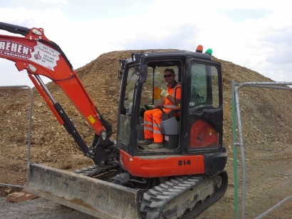
Remember
Do not enter an exclusion zones unless signaled by the operator.
Plant operators must not operate machine when unauthorized persons are in exclusion zone.
Any task that requires workers to enter zones, e.g. kerb laying, disconnecting attachments, slinging loads, off-loading materials, must have a safe system of work.
The safe system of work must be specific to your site. There must be a clear system of communication between the plant operator and workers performing the task.

